Transforming a Java Swing Student Registry System into a MERN-Based Student Appointment Scheduling System
Candy Naveda, Blessy Varghese, Danny Calderon

CS445_02_ON: Software Process Management – USADL – Winter 2025-2026,
Undergraduate Certificate in Cloud-Based Ai Powered Software Developer,
School of Technology & Computing
City University of Seattle

Abstract

This paper presents the progress of a software reengineering project that transformed a legacy Java Swing student registration system into a modern MERN-based student appointment scheduling system. The project applied incremental reengineering principles to preserve core functionality while introducing a distributed web architecture. During this phase, the system progressed from conceptual design to operational implementation in a cloud environment. The core architectural layers (frontend, backend, and database) are now publicly accessible and communicate successfully across distributed platforms. This implementation reflects structured software process management practices, including architectural redesign, phased validation, and risk mitigation (Pressman and Maxim, 2020; Boehm, 1988).

Keywords: software reengineering, legacy systems, MERN stack, GitHub Codespaces, software process management

Introduction
The goal is to transform a legacy Java Swing desktop system into a distributed web application based on MERN that facilitates appointment scheduling for student advising.
Software re-engineering focuses on improving an existing system while preserving its core business logic, rather than replacing it entirely (Pressman and Maxim, 2020). Since the previous milestone, the project has progressed from architectural planning to operational cloud implementation, validating distributed communication across all layers of the system.

Legacy System Analysis
The legacy Java Swing system served as a monolithic desktop application providing CRUD operations for student records. While functional, it exhibited several structural limitations.

Previously Identified Limitations
- Desktop-only execution
- No remote accessibility
- Limited scalability
- Tight coupling between UI and logic
- No authentication
- No scheduling functionality
Monolithic legacy systems often present maintenance and scalability challenges because tightly coupled components reduce adaptability to evolving requirements (Sommerville, 2016).

Current Resolution Status

Legacy Limitation | Current Resolution
Local execution | Web-based public access
Single-user | Multi-user web architecture
Local storage | MongoDB Atlas cloud database
Monolithic structure | Layered n-tier architecture
The original student data structure has been preserved and adapted as the foundational data model for the new system.
Target System Architecture
The project continues to use the MERN stack; however, the architecture is no longer conceptual—it is operational.

System Layers
- Frontend: React interface deployed on Vercel.
- Backend: Node.js and Express REST API deployed on Render.
- Database: MongoDB Atlas cloud database.
While the initial development environment was configured for GitHub Codespaces, the system has now been deployed to production-grade cloud platforms to validate real distributed operation.
The architecture follows a layered model separating presentation, application logic, and data management responsibilities. Layered architectures improve maintainability and flexibility by enforcing separation of concerns (Fowler, 2002).
The system communication follows REST principles, where independent components interact through stateless HTTP requests (Fielding, 2000).
The Figure 1 illustrates the transition from a monolithic desktop system to a distributed cloud-based layered architecture (Pressman & Maxim, 2020).

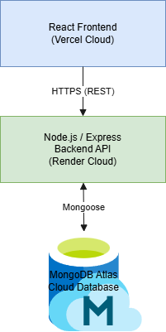
Figure 1
Reengineered MERN Distributed Architecture

Functional Mapping (Progressed)
The system has progressed from conceptual mapping to partial implementation and infrastructure validation.
Legacy Feature | New Implementation | Status
Add Student | User registration module | Implemented
View Student | Advisor dashboard | Implemented
Update Student | Profile management | Planned
Local storage | MongoDB Atlas | Implemented
No scheduling | Appointment module | In progress
Single user | Multi-user web | Implemented

Reengineering Strategy
The project follows an incremental reengineering approach:
- Reverse Engineering – Completed
- Requirement Extraction – Completed
- Architectural Redesign – Completed
- Forward Engineering – In progress
- Validation – Infrastructure validated
An incremental transformation strategy reduces risk by validating each integration phase before expanding functionality (Boehm, 1988). The authentication and communication layers have been validated, enabling functional scheduling logic to be implemented in the next phase.

Work Completed Since Last Report
The project has progressed from preparation to operational cloud deployment.

Infrastructure
- Backend server deployed to Render
- MongoDB Atlas connectivity verified
- React frontend deployed to Vercel
- Environment variables configured
- CORS and cross-origin communication configured

Integration Validation
- Frontend communicates with backend API
- Backend responds to external requests
- Distributed communication confirmed
- Public access verified
Figure2
Public Deployment of the React Frontend on Vercel
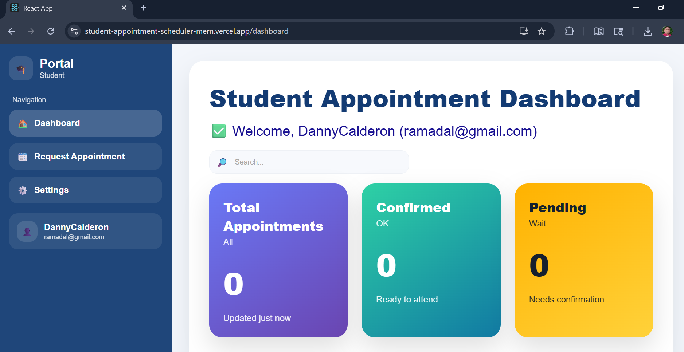
Note. Screenshot showing the publicly accessible React application deployed on Vercel, confirming successful frontend deployment and external accessibility. Student Appointment Scheduler Frontend
Figure 3
Backend Service Deployment on Render
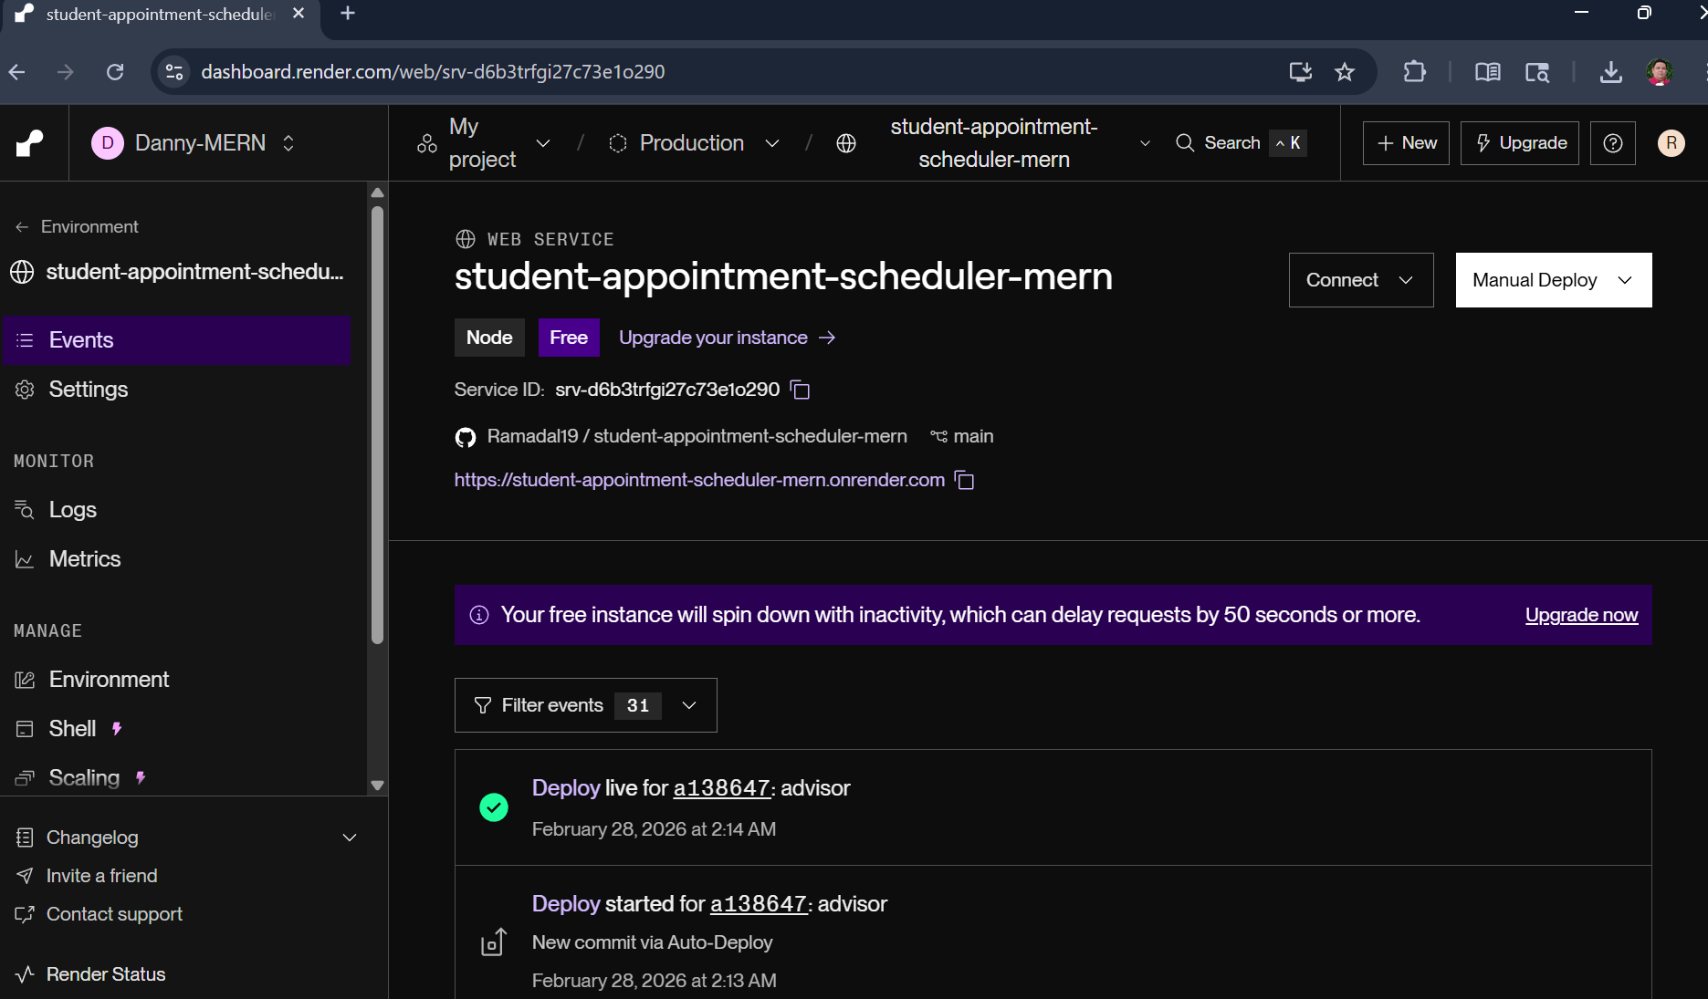
Note. Screenshot of the Render dashboard indicating active backend service status and successful production deployment. Student Appointment Scheduler Backend
Figure 4
MongoDB Atlas Cluster and Active Database Collections
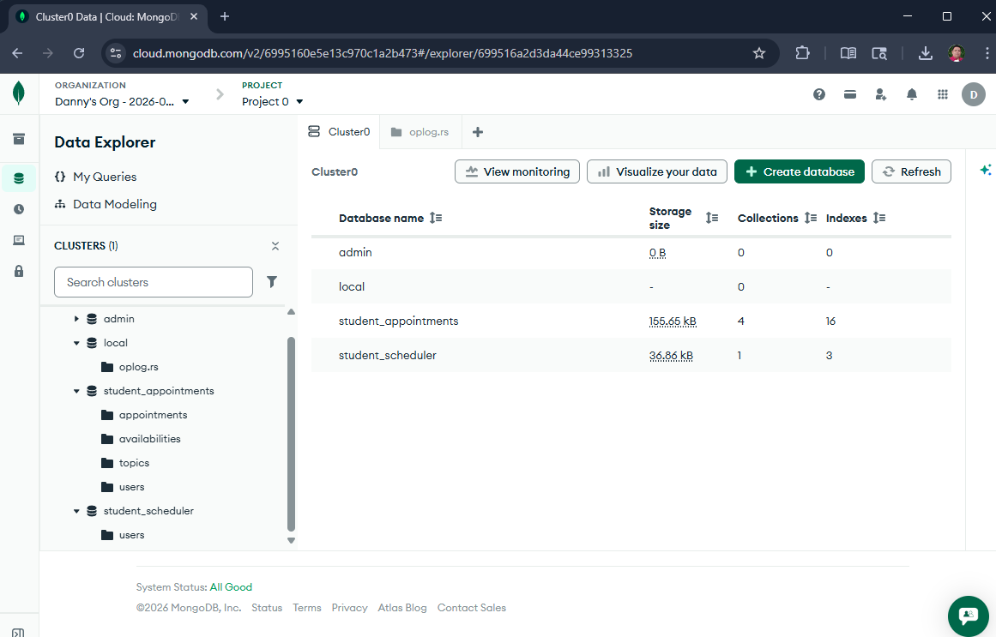
Note. Screenshot displaying the active MongoDB Atlas cluster and database collections supporting the deployed application.

Challenges and Risk Management

Challenges Encountered
- Cloud hosting port requirements
- MongoDB IP/network access restrictions
- Cross-origin request blocking
- Environment configuration differences

Mitigation Strategies
- Dynamic port configuration implemented
- MongoDB network access rules configured
- CORS policy adjusted
- Environment-based configuration introduced
These challenges shifted effort from code development to deployment engineering, demonstrating the complexity of distributed systems integration.

Process Evaluation
The project remains aligned with the incremental strategy defined in TP01. A larger-than-anticipated portion of Week 7 was dedicated to deployment and infrastructure validation rather than application logic. This shift highlights the importance of validating distributed environments early in the lifecycle.
The phased validation approach reduced integration risk and ensured that architectural decisions were verified before full scheduling implementation.

Next Steps
The next iteration will focus on completing the scheduling workflow within the deployed architecture. This includes finalizing advisor availability logic, appointment persistence, and validation rules to prevent booking conflicts.
The transition from infrastructure deployment to functional completeness reflects natural progression within incremental reengineering models (Boehm, 1988).
Additional system modeling artifacts—including updated sequence and deployment diagrams—will be aligned with the now-operational system architecture.

Conclusion
This progress report demonstrates measurable advancement from architectural planning to operational cloud deployment. The reengineered system is publicly accessible and validates communication across frontend, backend, and database layers.
This supports the view that reengineering is often more feasible than full system replacement when core business logic remains valuable (Pressman & Maxim, 2020).
The project remains on schedule, and the next milestone will focus on completing the core appointment scheduling functionality.

References
Boehm, B. W. (1988). A spiral model of software development and enhancement. Computer, 21(5), 61–72. https://doi.org/10.1109/2.59
Fielding, R. T. (2000). Architectural styles and the design of network-based software architectures. University of California, Irvine.
Pressman, R. S., & Maxim, B. R. (2020). Software engineering: A practitioner’s approach (9th ed.). McGraw-Hill Education.
Sommerville, I. (2016). Software engineering (10th ed.). Pearson Education.
Spinellis, D. (2006). Code quality: The open source perspective. Addison-Wesley.
Fowler, M. (2018). Refactoring: Improving the design of existing code (2nd ed.). Addison-Wesley Professional.

